Circle X

- 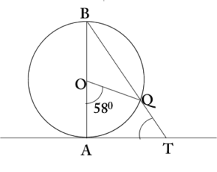In figure, AB is a diameter of a circle with centre O and AT a tangent If AOQ = 58° find ATQ
- 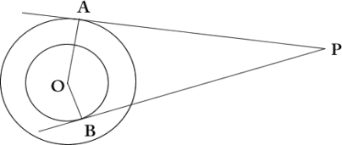Tangents PA and PB are drawn from external points to two concentric circles with centre o and radii 8cm and 5cm. If AP = 15cm find length of BP.
- 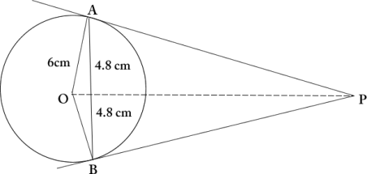
AB is a chord of length 9.6cm of a circle with centre o and radius 6cm. The tangents at A and B intersect at P. Find the length of PA.
- 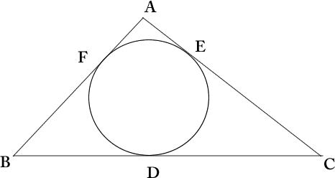A triangle ABC is drawn to circumscribe a circle of radius 3cm, such that the segment BD and DC into which BC is divided by the point of contact D are of length 6cm and 8cm. Find AB if area of ABC= 63cm²
- 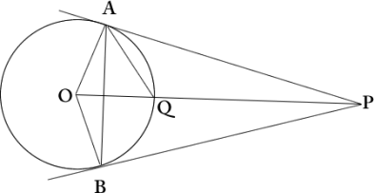
From a point P two tangents PA and PB are drawn to a circle. It OP=2r show that APB is equilateral
- 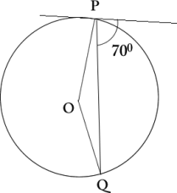If PT is a tangent to a circle with centre O and PQ is a chord of a circle such that QPT = 70, find POQ.
- 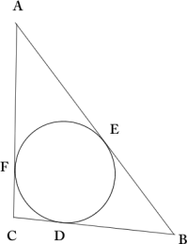ABC touches the sides AB, BC and CA at points D, E, F respectively. If AB=14cm, BC=8cm, and CA = 12cm. Find AF, BE, CF.
- 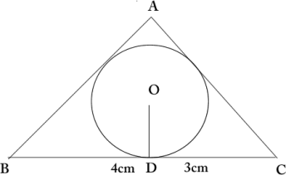
OD radius=2cm. If the area of ABC= 21cm² Find the length of sides AB and AC.

